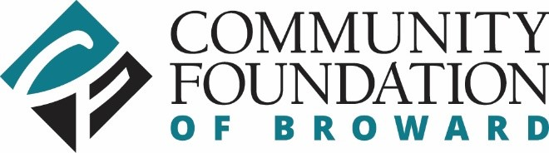
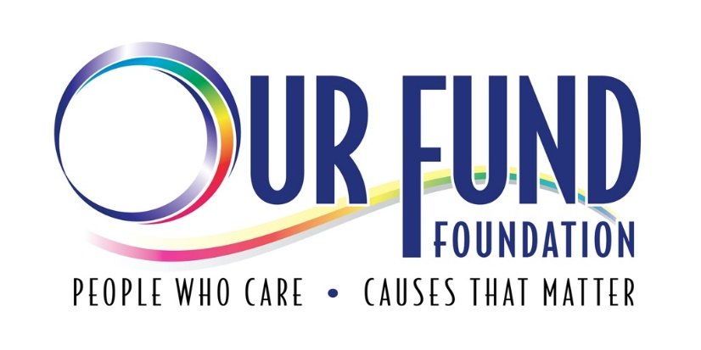

LGBTQ Social Justice & Equity
Funders Collaborative
2021 Request for Proposals

Proposal Deadline: Friday, December 10, 2021 by 11:59 PM ET

Our Fund Foundation
1201 NE 26TH Street, Suite 108
Wilton Manors, FL 33305
(954) 565-1090
Our-Fund.org

LGBTQ Social Justice & Equity Funders Collaborative
Request for Proposals

Our Fund Foundation and Community Foundation of Broward Collaboration

The Our Fund Foundation and Community Foundation Funders Collaborative desires to change the narrative of LGBTQ+ BIPOC (Black & Indigenous People of Color). Our collective goal is to invest in creating a more equitable community through an active commitment against racism and by taking actionable steps to effect meaningful and long-lasting structural change for LGBQ+ BIPOC. From our discussions regarding the need of this specific population, we believe our chosen area of focus with Social Justice & Equity will provide the greatest community impact.

LGBTQ Social Justice & Equity Request for Proposals

Focus: Building Paths to Equity in the LGBTQ+ Community

Equity ensures that all people are treated how they need to be treated to achieve the same results. In the social justice movement, this means such things as race-based incentives. For this RFP, we define social justice as the ability for LGBTQ+ BIPOC to have equal access to wealth, opportunities, and privileges within a society. Our focus on racial equity is for LGBTQ+ BIPOC to have the consistent quality of receiving fair and impartial treatment.

After a year of unprecedented social upheaval, a heightened social awareness around issues of racial justice and equity has risen among BIPOC Americans. LGBTQ+ BIPOC exist in a unique intersection of identities that give them a unique perspective of understanding the effects of inequities that both racism and anti-LGBTQ+ policies engender in their own community. Grants for Social Justice & Equity will support organizational efforts along these fronts to develop programs that will improve the lives of LGBTQ+ BIPOC, ensuring they are represented in all levels of the organization’s structure and programming, and that supported policies and practices have measurable and sustainable outcomes.
Funding Priorities

Projects must contribute to building civic and community engagement, awareness and capacity building, or provide programs and services around issues relating to LGBTQ+ BIPOC in Broward County. Proposed projects must fall in at least one of the priorities below:

Programming: The goal of culturally competent programming is to prioritize the particular identified needs of LGBTQ+ BIPOC, and address the unique systemic barriers that prevent BIPOC from achieving equity in a variety of arenas including health, education, socioeconomic status, and human rights, to name a few. Desired outcomes should focus on measurable impact to existing structures and policies, considering the root causes of systemic oppression.
Leadership: Beyond mere diversity initiatives, proposals under this funding priority should reflect a commitment to advancing racial equity in leadership development and assigned leadership roles. Material investments in LGBTQ+ BIPOC communities include making space for both organizational and community leadership opportunities for BIPOC people that can speak to the lived experiences of those whom the program is meant to serve.

Civic Engagement and Activism: Outcomes can focus on fostering engagement with community members that have been empowered with the capacity to continue advocacy work and ensure that advances take root and are sustained.

*Grants are made possible by Funds established at Our Fund and the Community Foundation of Broward.

Eligibility

To be eligible for funding, your organization must:
- Be a non-profit 501(c)(3) organization, or provide documentation that the organization is fiscally sponsored by an organization that has 501(c)(3) status
- Be either:
  - A LGBTQ-primary organization (defined as an organization whose mission includes the LGBTQ population as the primary focus of their work; whose staff and board predominantly reflect the LGBTQ community; and which primarily serves LGBTQ people); or
  - A non-LGBTQ-primary organization seeking funding for a LGBTQ-specific program/project should show a track record or history of serving the LGBTQ+ BIPOC community, or have an LGBTQ+ partnering organization that is BIPOC led.
- Request support for a project serving Broward County residents.
- Request support for a project occurring beginning April 2022. Implementation period is flexible.

Awards: The maximum Social Justice & Equity Fund grant award is $100,000.

Organizations can apply with a proposal up to a maximum of $100K.

Please note the following are not eligible for support:
- Requests for costs incurred prior to the date of the grant award
- Requests led by government agencies
- Requests for capital support, including construction and renovation
- Fundraising event sponsorship
- Organizations with outstanding grant project reports

Deadline and Timeline

Agencies interested in applying for and receiving grants from the LGBTQ+ BIPOC Social Justice & Equity Fund are encouraged to attend to have questions answered about the application, process and priorities for the LGBTQ+ BIPOC Social Justice & Equity Fund grants.

Application Start: Monday, November 1, 2021
Application Deadline: Friday, December 10th, 2021 at 11:59 PM
Q&A RFP Session: Tuesday, November 9, 2021 *will be recorded for post viewing
Panel Interviews with Finalists: Week of January 17th or 26th 2022
Grants Awarded: April 2022

The Community Foundation of Broward site will host the electronic applications.

Application Process

All applications are reviewed by program staff and then by a diverse community panel. The panel makes recommendations to the Board of Directors of Our Fund Foundation and Community Foundation of Broward.

LGBTQ+ BIPOC Social Justice & Equity Application

Section 1: Application Contact
Name of Organization *
Contact Person:
Title
Email Address *
Project Name
Project Focus
Project Duration (in months) *
Amount Requested *

Section 2: Organization Information
President/CEO/ED
Email Address
Mailing Address *
City *
State *
Zip Code *
Website
FEIN Number *
Phone Number *
Service Area: (Broward)
Organization’s Mission Statement
Annual Operating Budget:
Number of Full-time employees
Fiscal Sponsor (if applicable)
Address
Phone Number

Section 3: Grant Proposal

- 3A: Project Summary

  - State your project in one sentence using the following format:
“To provide (what services) to (how many) and (what target audience) so to/that will (improve what situation/condition) and (achieve which outcome).

  - Please provide a brief one-paragraph description of your proposed project.
- 3B: Community Need

- Explain how your project serves the needs of a diverse LGBTQ+ BIPOC community and advances social equity served with this program. Elaborate on the unique need that organizations historically have not, or currently are not, adequately addressing.

- 3C: Program Design

- Identify the funding priority your project will address: Programming, Leadership, Civic Engagement and Activism, or combinations. Give a detailed description of the project and implementation plan.

- 3D: Timeline

- State length of your project and any milestones to be achieved during project.

- Use included Timeline Template and attach/upload with application.

- 3F: Impact/Outcomes

- Describe measurable outcomes expected and the methods to be used in evaluating the success of the desired outcomes.

- Explain how the evaluation of your project will inform the development of this or future projects.

- 3G: Organizational Strength/Capacity

- How is your organization uniquely positioned to realize this project? - If you are not an LGBTQ+ BIPOC organization, state collaborations or partnerships that show commitment. If you are, list any programs or work that demonstrate your organization’s commitment to both LGBTQ+ BIPOC communities.

- Describe any efforts to collaborate with existing community projects. For project collaborations, please provide letter stating the responsibilities of each partner.

- Please describe the demographic composition of your board of directors and how their identities/expertise inform the goals of the project.

- Please describe the demographic composition of your staff and/or proposed staff and how their identities/expertise inform the goals of the project.

- 3H: Diversity, Equity & Inclusion

- Explain what initiatives your agency has taken to support staff, leadership and program participants in developing an inclusive, celebratory, and equitable environment.
- Explain how your project will involve leadership from LGBTQ+ BIPOC communities in meaningful roles that have impact on the success and scope of activities.

- 3I: Budget Justification/Narrative

- Use the Budget Template provided and in narrative form in this space, describe specifically how your budget will support the activities described.

- In the case your project or program is not fully funded, what would this project or program look like partially funded?

- Include a description of additional sources of income needed to complete program and whether additional sources are confirmed or planned.

Attachments

Please upload the following documents:
* Most recent audited financial statements or 12 months of financial statements (ask Amanda)
* IRS Letter of Determination of tax exemption under Section 501 (c)(3) of the Internal Revenue Code
* Fiscal Sponsor Agreement (if applicable)
* List of current board members with professional affiliations (We recognize that representation in leadership positions is an important step to ensuring racial equity and ensuring that a diverse range of experiences and perspectives are represented. To that end, please describe the general racial/ethnic composition of your current board of directors)
* Detailed Operating and Project Budget (Please use the included template)
* Statement of Responsibilities for each partner of project collaboration.
* Timeline Template
* Budget Template – all three tabs must be completed

